Written by Patrick Nyarukowa

Intermediate Nmap Writeup

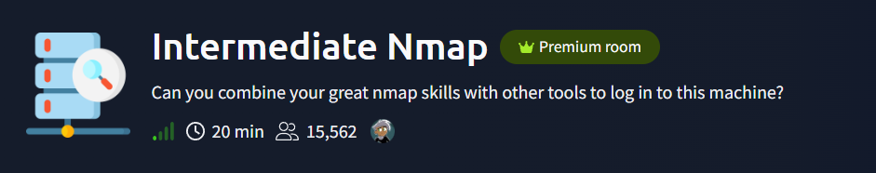

Introduction
In this writeup I will be walking you through the approach I took in completing the Intermediate Nmap room on Tryhackme. I will include the link to this room at the end as well as other resources I used to help me complete this room.

CTF Background
This CTF has an easy difficulty and the goal of this room is to practice our network scanning skills using the nmap tool and other protocols to log in to the target machine and find the flag. I will focus on capturing the flag.txt file.

Enumeration/Reconnaissance
As always, I started off by scanning the target machine using nmap
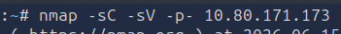
The nmap command can be broken down as follows:
- -p-: Scans all the ports.
- sV: Performs version detection for the services.
- sC: Performs a script scan using default scripts available in NMAP..
The result from the nmap scan showed that there are 3 ports open: SSH service on port 22, another SSH service on port 2222 and another service on port 31337. Also the login information left for the service on port 31337 — user “ubuntu” and password “Dafdas!!/str0ng”
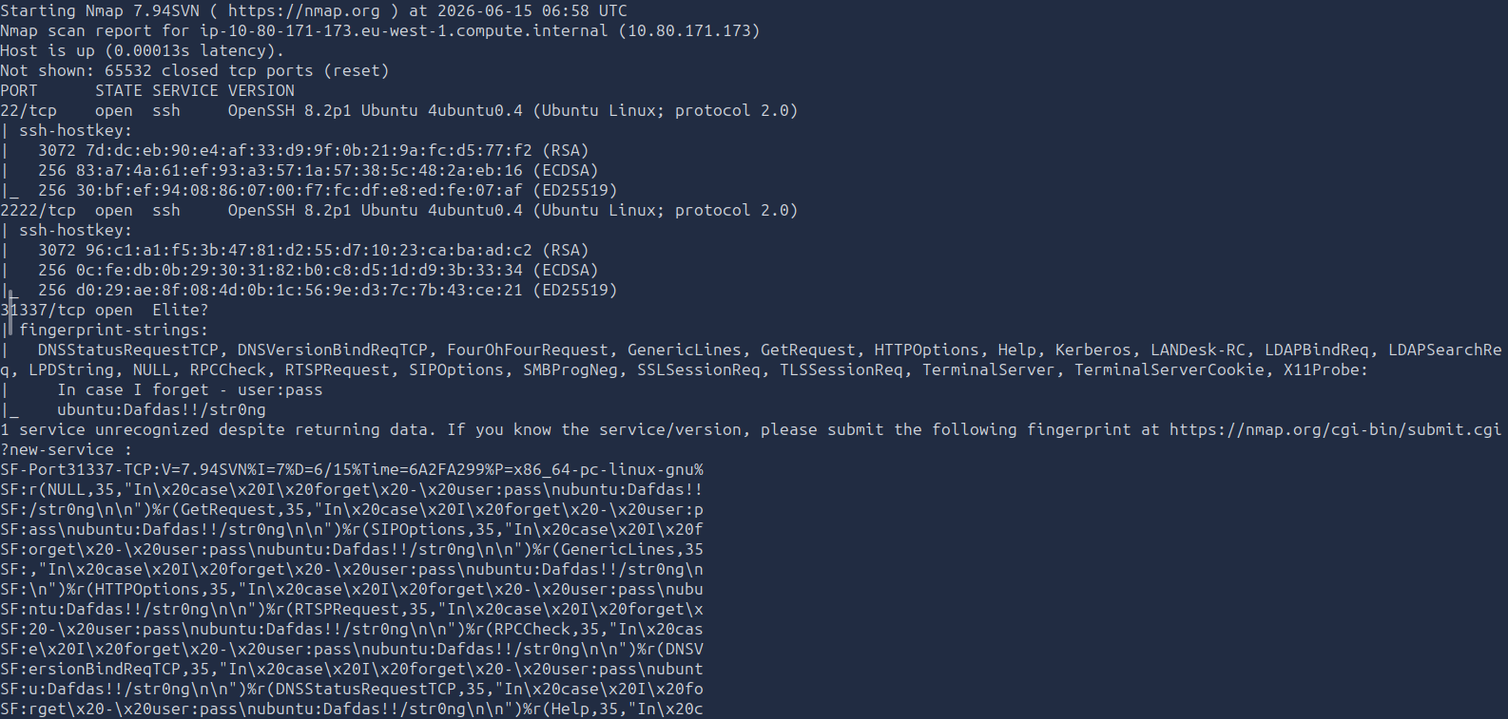

Finding the flag
In the nmap output we notice that the user credentials left under the service running on port 31337. We can assume that these could be credentials we can use to SSH into the service on port 2222 or port 22. We start of by trying to long into the service on port 2222:
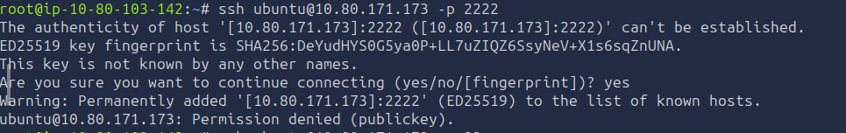
From the results we see that permission to log into the machine running on this service is denied. Next, we try again to log in the the target machine using the SSH credentials on port 22:
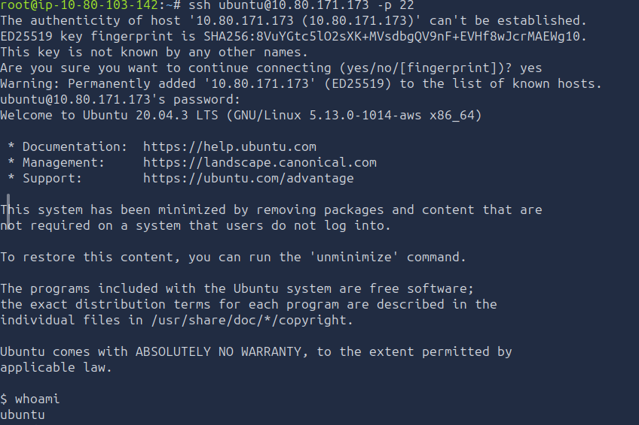
After attempting to log in we finally establish a connection and get access to the machine as the user ubuntu.
We not try to navigate the machine to look for the flag and we finally find it inside the user directory:
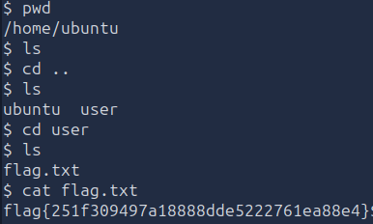

Takeaways
This was a fun and quick room to solve. It helped me in further re-enforcing my knowledge of using nmap to scan networks and find vulnerabilities in them. Thank you for reading this writeup and I hope you enjoy tackling this room as much as I did.

References
- https://tryhackme.com/room/intermediatenmap?vccr=1

